Target 100
Use a 30-sided dice. Here is a link to a dice-roller online http://www.roll-dice-online.com/
There is also a link on the ‘At Home Activities’ page on my website. Get a whiteboard or scratch paper, roll the dice 4 times and write your numbers down. Now you use those numbers to get as close to 100 as possible. You may add, subtract, multiply, or divide.

Target
This is another version of the game. You roll the 30 dice to determine the target number. Then everyone rolls a 6-sided dice 5 times. Write those numbers down. Now add, subtract, multiply, or divide to get the target number exactly.

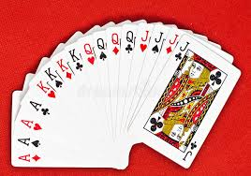

Computation Review
With a deck of cards, you can work on all levels of computation. You can add, subtract, multiply, and divide. Flipping cards makes practicing not seem so tedious and repetitive. You can even add a regular dice that they roll to decide how many cards to flip. Here are some appropriate levels by grade.
1st grade: flip two cards, toss a coin, heads they add, tails they subtract
2nd grade: flip up to 3 cards on top and 2 cards on bottom, then add or subtract.
3rd grade: flip up to 4 cards on top and 3 cards on bottom, then add or subtract. Flip 2 cards and practice multiplication facts.
4th grade: up to 5 digits on top and 4 on bottom, add or subtract. Up to 3 digits by 2 digits for multiplication. Up to 4 digits divided by 1 digit for long division.
5th grade: up to 5 digits on top and 5 digits on bottom, add or subtract. Up to 5 digits by 4 digits for multiplication. Up to 6 digits divided by 3 digits for the long division.

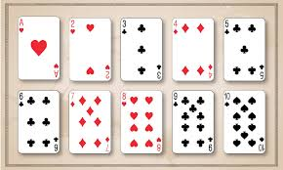

Garbage/Trash
This game is fun for all ages and is great if you have a younger child who is working on numbers and even adding.
Needed
Two or more players; 52 card deck (additional decks are needed for four or more players)
Deal
To start, deal ten cards to each player. The remaining deck is placed in the middle. The cards remain face down. Setup your cards in a straight row.
Objective
The object of the game is to be the first player to line up your cards in a sequence starting with the ace.
Game Play
The player left of the dealer goes first by drawing the top card from the middle deck. In the first round each player has ten card spots. The spots are numbered 1 to 10 starting from the left. When a numbered card is drawn, the card is placed in the corresponding spot.
For example, a 5 drawn will be put face up in the fifth spot on your row. The face down card in the 5 spot is flipped up and moved accordingly. When player can no longer make a move, a discard takes place to end the turn.
The next player to the left can choose to take the top discard or draw the top card of the deck.
The kings are wildcards and can be put in any spot. The jacks and queens are garbage and are discarded when picked up. Aces are used for the 1 spot.
Winning
Once a player has flipped up all his/her cards, each other player gets one more turn.
All the players that were able to flip up all ten cards will only be dealt nine cards in the next round and will only need to get a sequence of 1 to 9. Players that did not flip up all the cards will have to play the next round with ten cards again.
Play continues this way with winning players going down one card, and losing players replaying with the same amount of cards as the previous round.
The first player to flip an ace in his/her last round wins the game.
Rules
- When a player flips up all his/her cards the other players get one more turn. If on that last turn a player can flip up all his/her cards, he/she will also go down one card for the next round.
- Wildcards can move. For example, a player with a wildcard in the 2 spot that draws a 2 can replace the wildcard with the 2. The wildcard can then be moved to a different spot.

Number Island

Circle 2 or more neighboring numbers that add up to 10
*Numbers must be side-by-side, up-and-down, or diagonal
*Once a number is circled, it is out of play for the rest of the game
Try to claim every number on the board.
Here’s an example of how to play:

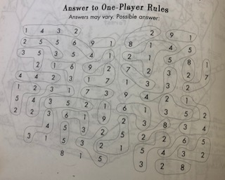

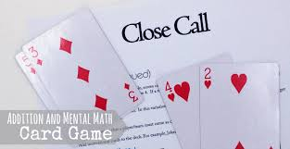

Close Call
To play Close Call, each player deals themselves four cards then determines how to arrange them, so they make two two-digit numbers that add up close to 100 without going over. For a subtraction version, work to get as close to zero as possible.

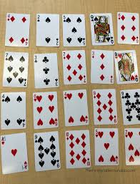

Total 10
Play this math card game alone or as a team. Lay out 20 cards on the table (leave out face cards or change them to equal 0, while aces equal 1). Kids remove sets of cards that add up to 10, ultimately trying to remove all the cards from the table. It’s harder than you think!

Beat the Parent
Practice place value by drawing cards and trying to build the largest number possible. You can decide how many cards to draw or roll a dice each round to mix it up a bit. Kids can play against the parent or each other to see who wins!

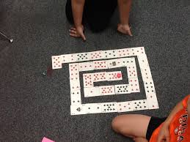

Around the Spiral
You’ll need a pair of dice for this math card game. Lay cards out randomly in a spiral formation as shown and set a marker for each player on the center card. Player one rolls the dice then moves their piece that number of spaces shown. They then must multiply (or add or subtract, depending on preferences) the card number by the number on the dice. If they get the answer correct, they stay where they are. If not, they return to their original card. Play continues until one player reaches the end.

